

CUSTOMER CARE REGISTRY

**SOLUTION ARCHITECTURE**

# TEAM DETAILS:



**Team No :** PNT2022TMID51192

**College Name :** AAA College of Engineering & Technology

**Department :** Computer Science & Engineering

# PROJECT MEMBERS :

* SRIRAM SELVAKUMAR S
* G SIVA ANANDAVEL
* AAKARSH S U
* SURAJ RAM S

Solution Architecture 2

# PROJECT DESIGN PHASE –I

ARCHITECTURE

|  |  |
| --- | --- |
| **DATE** | **16.10.2022** |
| **TEAM ID** | PNT2022TMID51192 |
| **PROJECT NAME** | CUSTOMER CARE REGISTRY |
| **MAXIMUM MARKS** | -------- |

Solution Architecture 3

# PROJECT DESIGN PHASE –I

ARCHITECTURE

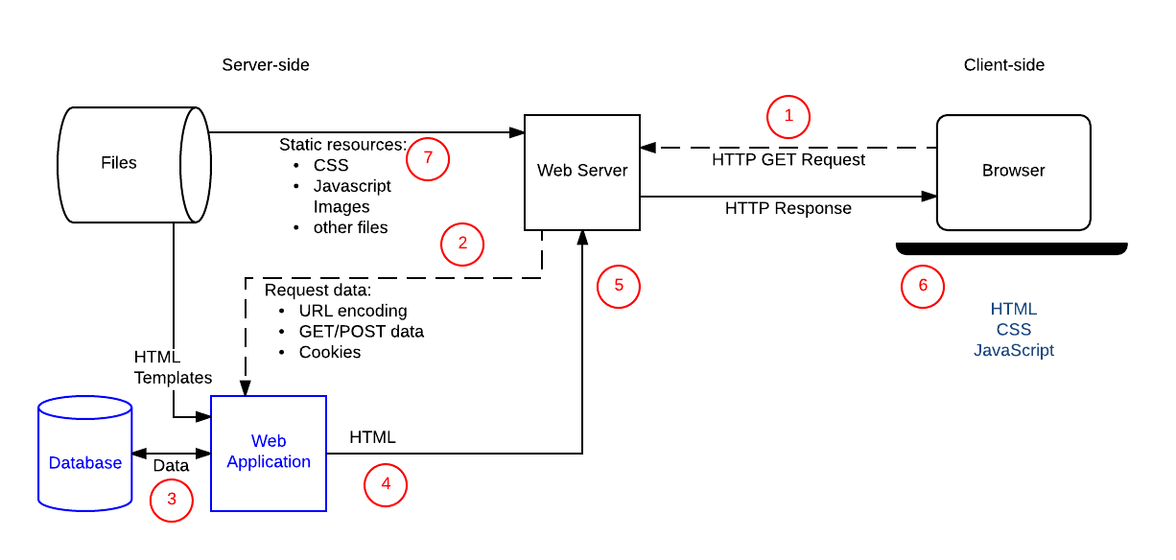

Solution Architecture 4

TECHNICAL ARCHITECTURE

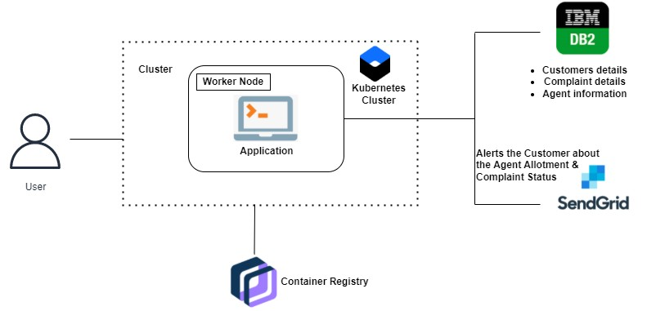

Solution Architecture 5



**Thank you**